1. **What is Exploratory Testing?**

tester actively explores the application while testing it, instead of strictly following a set of pre-written test cases.

1. **What is traceability matrix?**

A Traceability Matrix is a document that links requirements to their corresponding test cases.

1. **What is Boundary value testing?**

Boundary value testing is a methodology for designing test cases that concentrates software testing effort on cases near the limits of valid ranges.

1. **What is Equivalence partitioning testing?**

Equivalence partitioning is Instead of testing every possible input, you group similar inputs together and test only one value per group because if one input works the others probably will too.

1. **What is Integration testing?**

Integration Testing is checking how different modules or components of an application work together.

1. **What determines the level of risk?**

Risk analysis should be used to determine what to test in each component and just as importantly what not to test.

1. **What is Alpha testing?**

Testing conducted by internal team with virtual environment and within organization that called.

1. **What is beta testing?**

Testing conducted by customers at own location site with Real world environment that called.

1. **What is component testing?**

Component Testing also called Module Testing or Unit Testing .when you test individual parts of a software application by themselves, to make sure each one works properly.

1. **What is functional system testing?**

Functional System Testing where you check the entire system to make sure it behaves according to the functional requirements.

1. **What is Non-Functional Testing?**

Non-Functional Testing is focuses on the non-functional aspects of a system and things that describe how the system performs rather than what it does.

1. **What is GUI Testing?**

Testing how the app looks and interacts from the user’s perspective, focusing on things like buttons, menus, text, icons, and the layout.

1. **What is Adhoc testing?**

Adhoc Testing is an informal type of software testing where you randomly test the application without following any structured test plan or documentation and it aim is break the system.

1. **What is white box testing and list the types of white box testing?**

White Box Testing also called Glass Box Testing. In white box testing you look inside the code and test how the system works internally.

There are three types of coverage:

1.Statement coverage

2.Decision Coverage

3.Condition Coverage

1. **What is black box testing? What are the different black box testing techniques?**

Black Box Testing is a type of software testing where you test the system from the outside, without looking at its internal code or structure.

There are Four types of Techniques:

1. Equivalence Partitioning
2. Boundary Value Analysis
3. Decision Table Testing
4. State Transition Testing
5. **Mention what bigbang testing is?**

Big Bang Testing is a type of Integration Testing where all modules of the system are combined together at once and tested as a whole.

1. **What is the purpose of exit criteria?**

Exit Criteria is specific conditions or requirements that must be met before testing can stop

-To make sure the software is ready for release or the next phase.

-To ensure quality by confirming that key tests have been completed.

- To avoid stopping testing too early, missing important bugs.

- To measure whether testing goals were achieved.

1. **When should "Regression Testing" be performed?**

Regression Testing should be performed whenever there is a change in the software like a new feature added, a bug fixed, or a modification made to make sure that the existing functionality still works properly.

1. **What is 7 key principles? Explain in detail?**
2. Testing Shows Presence of Defects: Testing can show that bugs exist, but it can never prove that All software is bug-free.
3. Exhaustive Testing is Impossible- You cannot test everything every input combination, every path, every scenario.
4. Early Testing- The earlier you start testing because is easy to fix.
5. Defect Clustering- In most software, a few modules usually contain most of the bugs.
6. Pesticide Paradox- If you keep running the same tests over and over, eventually they stop finding new bugs.
7. Testing is Context Dependent- Different projects need different strategies.
8. Absence-of-Errors Fallacy-All defects resolved but it may still unusable and does not fill user requirements.
9. **Difference between QA v/s QC v/s Tester:**

QA-Activities which ensure that implementation of process, procedures &standards in context to verification of developed software & intend requirements.

QC-Activities which ensure the verification of developed software with respect to documented requirements.

Testers-Activities which ensure the identification of bugs/error/defects in the software.

1. **Difference between Smoke and Sanity?**

Smoke-Smoke testing is performed to ascertain that the critical functionalities or the program is working fine.

Sanity-sanity testing is done to check the new functionality bugs have been fixed.

1. **Difference between verification and Validation**

Verification-The process of evaluating work products or development phase to determine whether they meet the specified requirements for that phase.

Validation-The process of evaluating software during or at the end of the development process to determine whether it satisfies specified business requirements.

1. **What is Error, Defect, Bug and failure?**

Error-A mistake in coding that called Error.

Defect-Error found by tester that called defect.

Bug-Defect accepted by development team that called bug.

Failure-Build does not meet with requirement then it is failure.

1. **Explain the difference between Functional testing and Non-Functional testing**

Functional testing-It is performed using functional specification provided by the client & verifies the system against the functional requirements.

It describes what the product does.

Non-functional Testing-It is checks performance, reliability, scalability & other non-functional aspects of the software system.

It describes how good the product works.

1. **What is the difference between the STLC (Software Testing Life Cycle) and SDLC (Software Development Life Cycle)?**

STLC- It’s the process of testing the software to make sure it's working correctly and meets quality standards.

SDLC=- It’s the complete process of developing software from the idea to the final product.

1. **What is the difference between test scenarios, test cases, and test script?**

Test Scenarios-A scenario is any functionality that can be tested.it is also called test condition or test possibility. Test scenario is ‘what to be tested’.

Test case- It involves the set of steps, conditions & input which can be used while performing the testing tasks. Test case is ‘How to be tested’.

Test Script- A set of instructions that will be performed on the system under test to test that the system functions as expected.

1. **Explain what Test Plan is? What is the information that should be covered.**

A Test Plan is a document that describes the strategy, objectives, resources, schedule, and scope of testing activities for a project.

It’s Covered:

Test Objectives

Scope

Test Strategy

Resources

Test Environment

Schedule

1. **What are the different Methodologies in Agile Development Model?**

Scrum

kanban

1. **Explain the difference between Authorization and Authentication in Web testing.**

Authorization – user authorities are check for accessing the resource

Authentication - identify of the users are checked for providing access to the system.

1. **What are the common problems faced in Web testing?**

1. Browser compatibility issues

2.Responsive Design Problem

3. broken links

4.Performance issues

5. Session management problems

6. Functionality Error

7. third-party integration failures

31.**What is Bug Life Cycle?**

The defects is found and the time that it is closed successfully, rejected, postponed or deferred is called as bug life cycle.

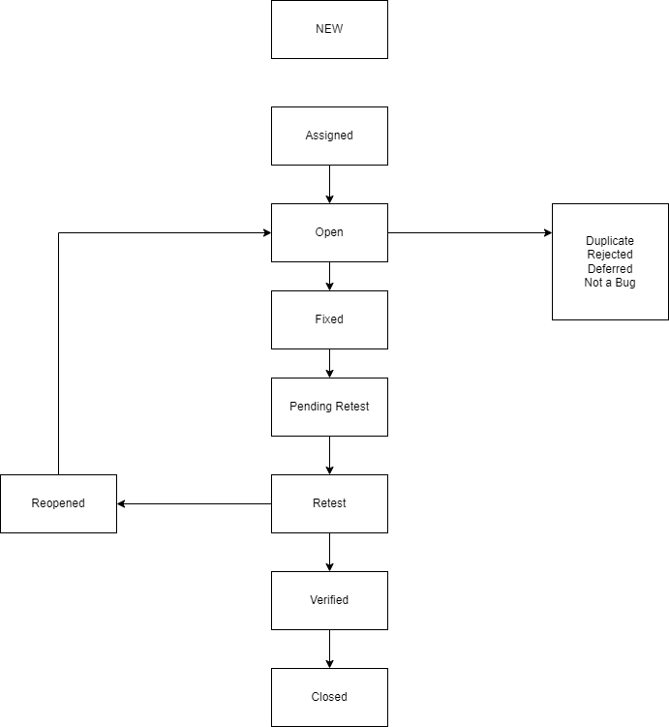

32.**Difference between priority and severity**

-Priority – priority determines the defect urgency of repair.

-How soon we need to fix.

-Priority is given by test lead or project manager.

-Levels – fix before next build to test, fix before final release

-Severity – severity determines the defects effect on the application

-How bad the defect is

-Severity is given by QA testers

-Levels – critical, High, Medium, Low